**APPLICATION DEVELOPMENT FOR FINDING FLATMATES**

**GO TO MARKETING STRATEGY:**

**Serviced apartments are in trend among guests for experiencing the comforts of a hotel without any hindrance to their privacy. With multiple properties present in the town, you need to level up your marketing game to be prominent among customers and**[**boost your service apartment’s profitability**](https://www.ezeeabsolute.com/blog/make-your-serviced-apartment-business-profitable/?utm_source=ServicedApartmentMarketing&utm_medium=blog&utm_campaign=eABlog)**.**

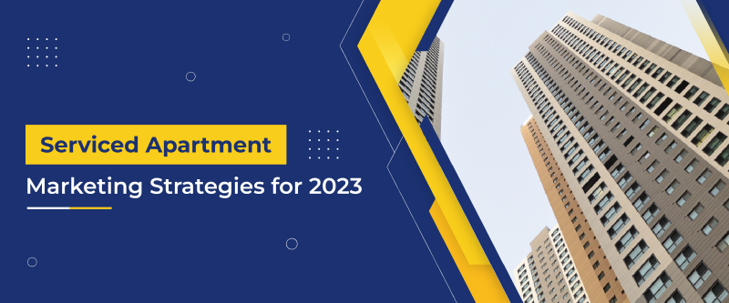

**How to market serviced apartments?**

**1. Identify your guests:**

**One of the critical steps in any marketing strategy is identifying the target audience. Do you know about 80% of the content is marketed to the wrong audience?**

**Every time you promote your property among incorrect**[**guest segments**](https://www.ezeeabsolute.com/blog/hotel-guest-segmentation/?utm_source=ServicedApartmentMarketing&utm_medium=blog&utm_campaign=eABlog)**, all the effort and money goes in vain. Talking about the target audience for serviced apartments, there are four major verticals, which you can focus on:**

1. **Guests looking to spend a long vacation with their family in a homely environment**
2. **Corporate employees on an extended business tour**
3. **International guests**
4. **People relocating to the city looking for temporary accommodation.**

**After the pandemic, organizations initiated work from home (WFH) policy. For a change and to avoid the hassles of domestic chores, many corporate employees are opting for serviced apartments. The duration of their stay may vary from 1 week to a couple of months.**

**2. Connect with corporate organizations:**

**As I said earlier, business travellers and working professionals vouch for serviced apartments, if they have a prolonged stay.**

**It’s better to leverage this opportunity by working in cohesion with these organizations. You can have a strategic partnership with IT firms, MNCs, BPOs, KPOs, and other such organizations facilitating WFH policy for employees.**

**However, you need to have a flexible tariff structure that should be beneficial for you and the partner organization. It’s better to introduce corporate rates for this guest segment like weekly and monthly tariffs.**

**Moreover, these corporate organizations have recurring projects and business meetings. So, definitely, it is an excellent marketing strategy for serviced apartments.**

**3. Invest in a website:**

**Websites are mandatory for every hospitality business. And, a**[**brand website**](https://www.ezeepanorama.com/blog/importance-of-brand-website/?utm_source=ServicedApartmentMarketing&utm_medium=blog&utm_campaign=eABlog)**can make you stand out from the crowd.**

**Websites create the 1st impression on your guests, and this applies to serviced apartments also. It’s important to have engaging content with high-quality photographs of your property to capture guests’ attention.**

**Invest in a**[**website builder**](https://www.ezeepanorama.com/?utm_source=ServicedApartmentMarketing&utm_medium=blog&utm_campaign=eABlog)**that is easy to use while making relevant updates. Moreover, don’t forget to optimize it for better conversions. Once you’ve built your website, link it to your**[**Google My Business listing**](https://www.ezeeabsolute.com/blog/google-my-business-for-hotels/?utm_source=ServicedApartmentMarketing&utm_medium=blog&utm_campaign=eABlog)**and your serviced apartment’s social media pages.**

**4. Promote your property with photography:**

**One of the reasons why many serviced apartments go unnoticed is the bad quality of photos.** **Sometimes there are photos of every room, but they are either blurred or distorted. See, these kinds of pictures create a negative impression in front of guests.**

**And, this is why there is a saying – what you see is what you get.** **You can click some good pictures from your smartphone in portrait mode, with a minimum resolution of 1800*1200 pixels. Moreover, you can enhance them using various photo editing apps like**[**Adobe PS Express**](https://www.adobe.com/in/photoshop/online/photo-editing.html)**,**[**Snapseed by Google**](https://play.google.com/store/apps/details?id=com.niksoftware.snapseed&hl=en_IN&gl=US)**, or**[**Picsart**](https://play.google.com/store/apps/details?id=com.picsart.studio&hl=en_IN&gl=US)**.**

**5. Social media pages and groups can do wonders:**

**Over time, social media platforms evolved from making friends to generating business. Today, millions of businesses have their presence across social media.**

**In fact, Facebook has a separate feature known as ‘Marketplace’, for business-minded people. If you haven’t created your serviced apartment’s page on social media platforms, do it NOW.**

**Another reason for doing so is to stay connected with city groups. As you might be aware, people before relocating to new places, search for accommodation in real-estate groups, like flats and flatmates in Mumbai, serviced apartments in Delhi, New York homes, flats, and PGs in Bangkok.**

**You can post about your serviced apartments in these groups to capture leads.**

**6. Highlight your locality and nearby facilities:**

**One of the prime factors guests checks while booking a serviced apartment is its locality and nearby facilities. The former defines if the area is safe and sound for living, and the latter depicts the ease of access to daily needs.**

**Guests prefer serviced apartments that are located in close proximity to hospitals for emergencies. Also, nearby facilities like shopping marts, pharmacies, and restaurants.**

**If your property is located at a tourist destination, you can promote local attractions. Try to include them in your content.**

**Blogs on these places to visit can definitely help in increasing your guest engagement. Also, highlighting the proximity of these locations from your serviced apartment can increase the chances of guests booking it.**

**7. Turn to WhatsApp messaging:**

**WhatsApp is currently one of the main channels of communication in the hospitality industry.  It not only provides assistance to travellers but also converts direct bookings. So, it makes complete sense that you make WhatsApp a part of your marketing plan for your apartment.**

**WhatsApp business comes with a bundle of features that allow you to craft an end-to-end marketing strategy. With the right tactics, you can reach out to a large audience, maximize guest satisfaction, develop strong customer relationships, and increase sales.**

**8. Partner with other businesses:**

**The serviced apartment industry is saturated. With so many options for lodging, aparthotels must go above and beyond to make their services stick out. And**[**partnering with other businesses**](https://www.ezeeabsolute.com/blog/partnership-marketing-for-hotels/?utm_source=ServicedApartmentMarketing&utm_medium=blog&utm_campaign=eABlog)**can be an excellent way to tap into new clientele.**

**Businesses can create larger promotions while enjoying greater cost savings when they team up. And if you follow this for your serviced apartment, you can save time and money on separate promotions and work together to create an impactful marketing campaign.**

**REPORT CREATED BY**

**FAHAD IQBAL SHAH**

**PRODUCT MANAGEMENT INTERN**

**NOVO CABS**